**Filling in the aging file**

Start with downloading the payments list and check if all payments are cleared.

Home – List - Payment Statistics – Customers

Selection:

* Company has to include the 4 legal entities (absolute value)
* Proposed Posting Date: Friday to Friday
* Display currency has to be in euro

EXPORT to EXCEL

Check open payment in Receivables – Customer Account

**If ok go to:**

SAP: Receivables -> List -> Aging List For Receivables With Journal Entry Details

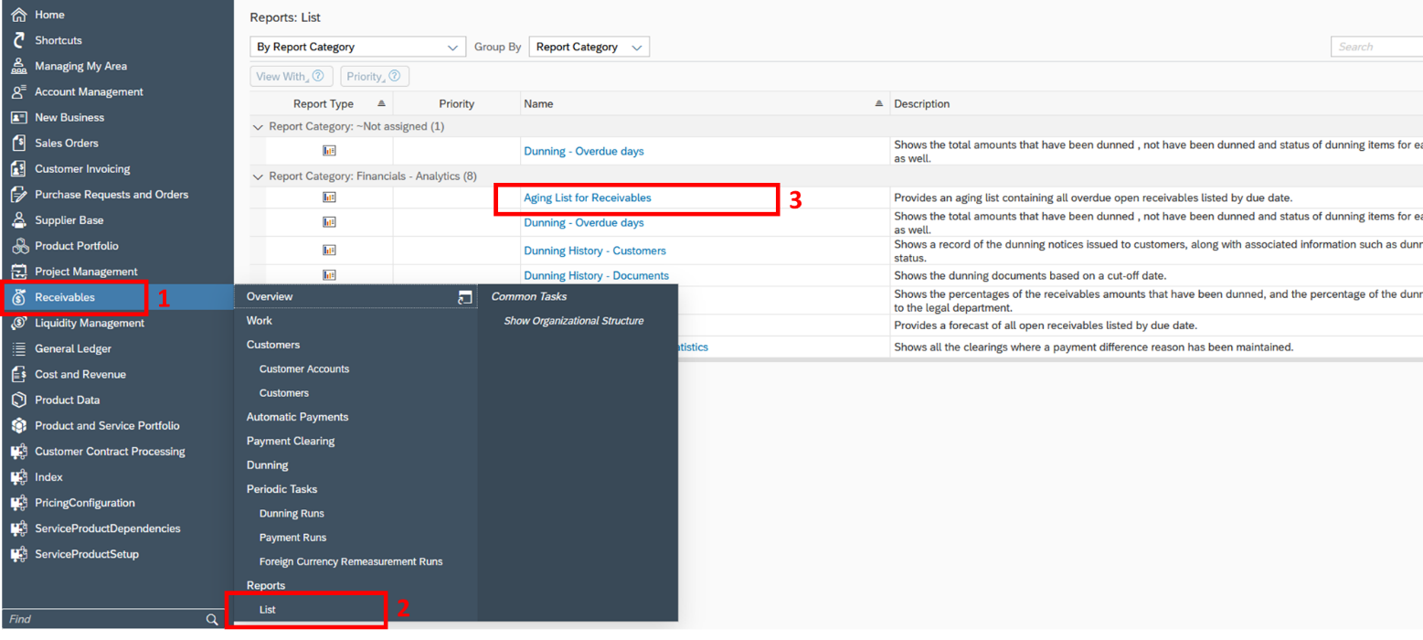

Adjust parameters by clicking the squares and selecting the correct parameter + OK

* Company has to include the 4 legal entities (absolute value)
* Display currency has to be in euro

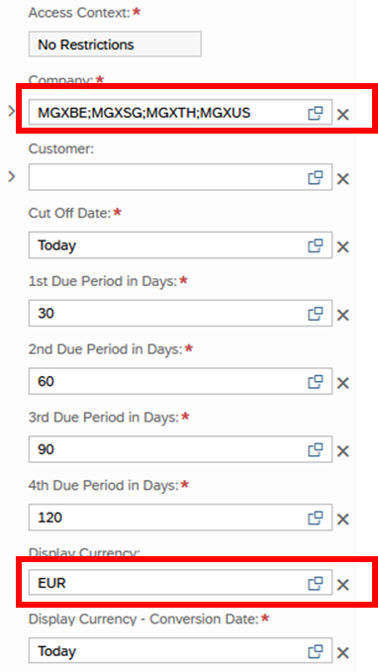

In the View tab, adapt the parameters to include the concerned company & G/L Account:

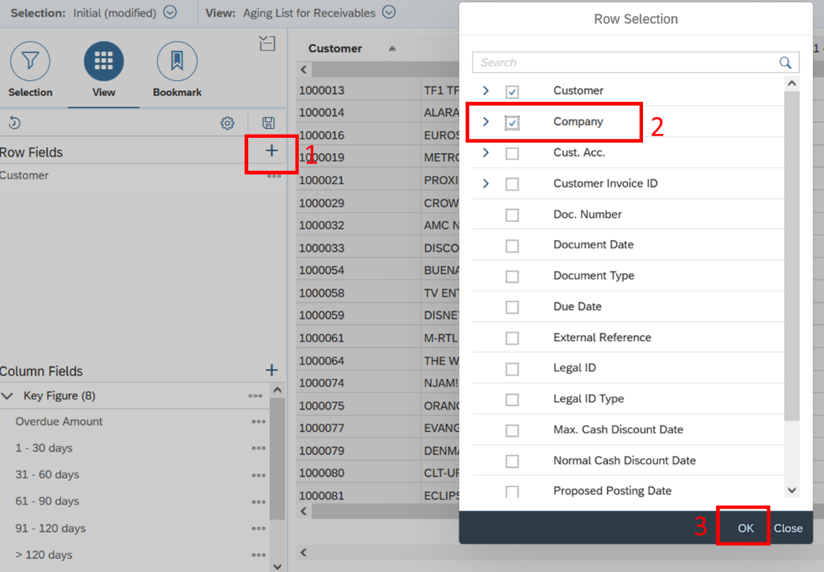

Move “G/L Account” and “Company” above “Customer” to have that information in the first column of your report

Hide the results row by clicking the 3 dots next to Company > Characteristic Settings > Do Not Show results row

Show result on G/L account level

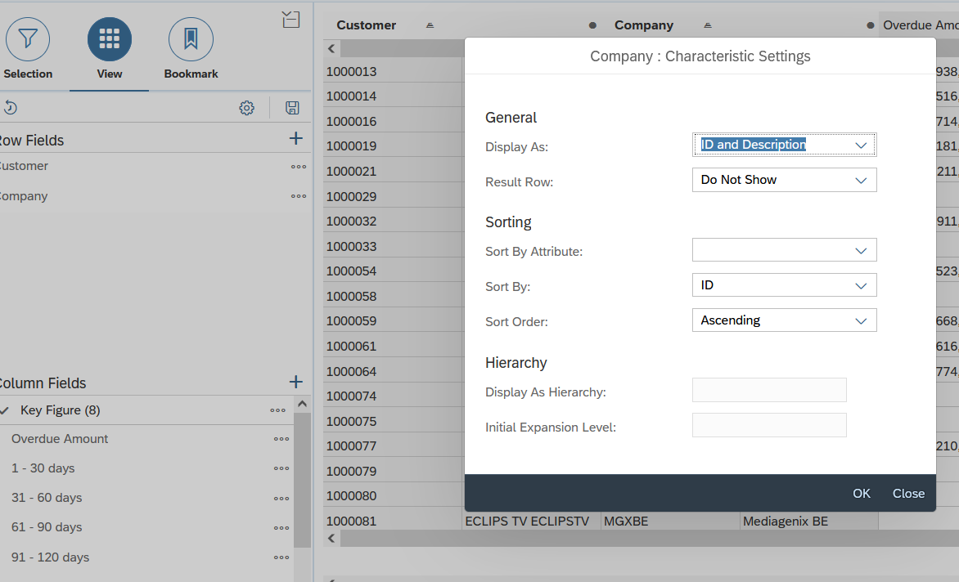

Add the display repeated text:

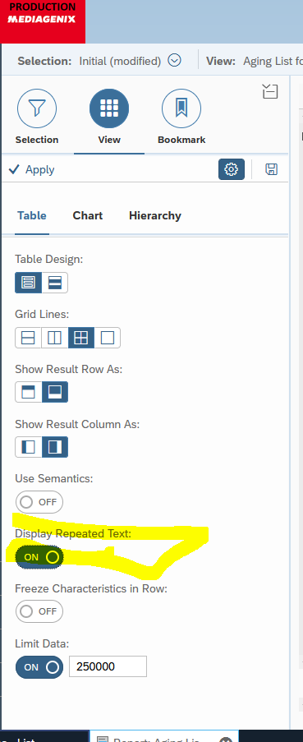

The dates must be changed If the file has not been created the Friday (date of the regular aging day)

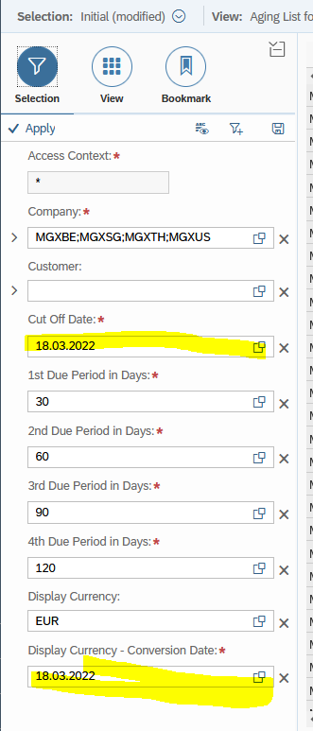

Start the report > Export list by clicking Share  > Download > Report in Microsoft Excel in XML format

1. Adjust lay-out of document to match previous reports: (TAB 1: Export tab)

* Delete the first empty column
* 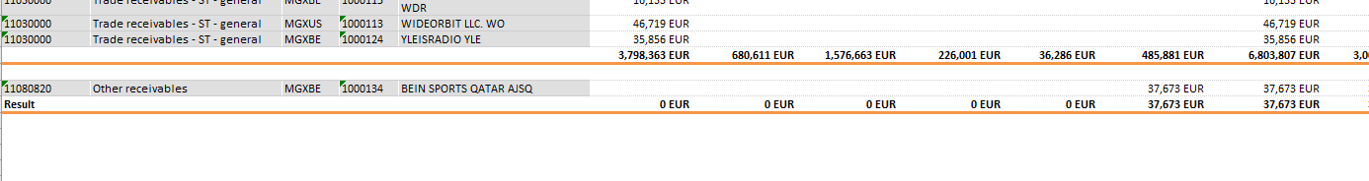

the Qatar withholding amount does not need to be included ( Qatar “other receivables “needs to be separated) and Advance received from customers

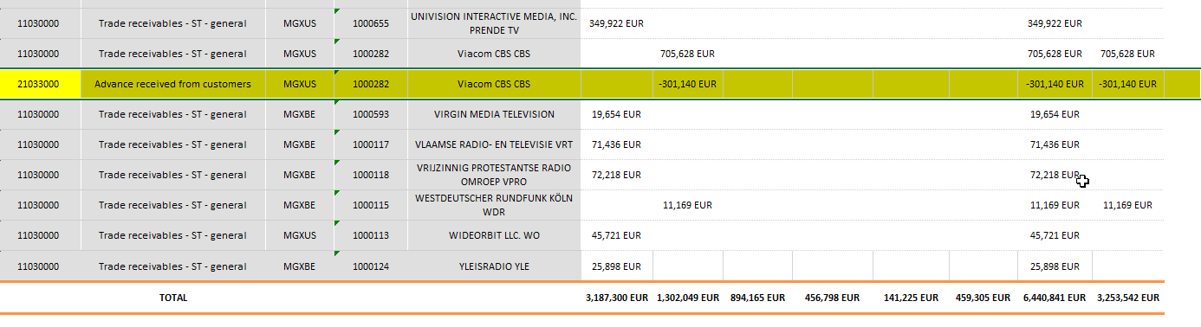

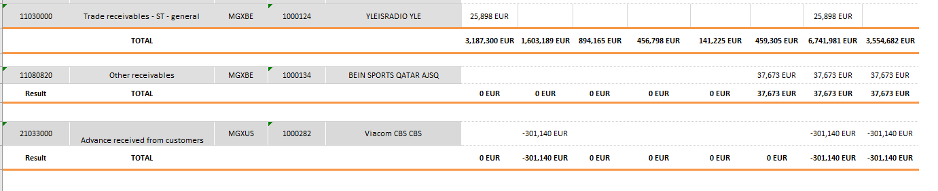

* Delete the first 19 lines of information
* Adapt the font to Calibri (body) and size 9
* Delete the column with the full company name as the abbreviation column is enough (Column 4)
* Adapt all the amounts in your report to be without a comma
* Do this step after moving the intercompany and doubtful debt to different tabs. Recalculate the total amount, as the intercompany lines and the doubtful debtors have been removed. (**All companies from MEDIAGENIX need to be copied and pasted in tab 2 and after deleted in tab 1)**

1. Intercompany Debt (TAB 2)

* Move the intercompany lines from the TAB 1: Export tab to a separate tab. So they are not taking into account in the general calculations.

1. Doubtful Debt (TAB 3)

* Exclude the doubtful debt by moving the lines from the TAB 1: Export tab and paste it in a different tab.

1. Calculate the history (TAB 4)

* Copy paste the historical ageing from last week’s aging file and add a new line at the bottom for the results from last week.
* Calculate % overdue: Overdue Amount/ Outstanding Amount
* Make a new chart which include outstanding amount and overdue amount of 1 year.

Making chart: choose time frame for a year ( for example from October last year till October this year) and Outstanding Amount (click Ctrl for adding 2 columns in the same time) , Then add the Overdue Amount . Change the Legend name (edit button)

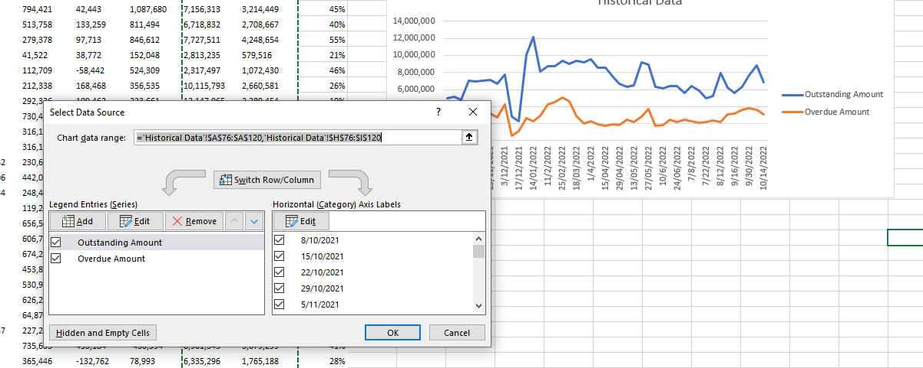

1. Overview of the 9 largest open amounts (TAB 5)

Copy new data from Export this week

* Put a filter on your first tab and sort it from highest overdue amount to lowest
* Copy paste the customers with the highest overdue amounts into the new week
* Copy paste the comments from the previous week and adjust where necessary based on actions that were taken during the week

1. 90-120 days (TAB 6)

* Use the first tab to access the oldest outstanding amounts
* Filter the 91-120 days tab from largest to smallest + copy paste all of the customers + the amount that has been outstanding for +90 days
* Filter the >120 days tab from largest to smallest + copy paste the amount that has been outstanding for +120 days

All negative amounts do not need to be included

* Use a Vlookup function to copy-paste the comments from last week for every customer and AM

1. Register the payments (TAB 7)

SAP > Home > List > Search for Payment Statistics – Customers

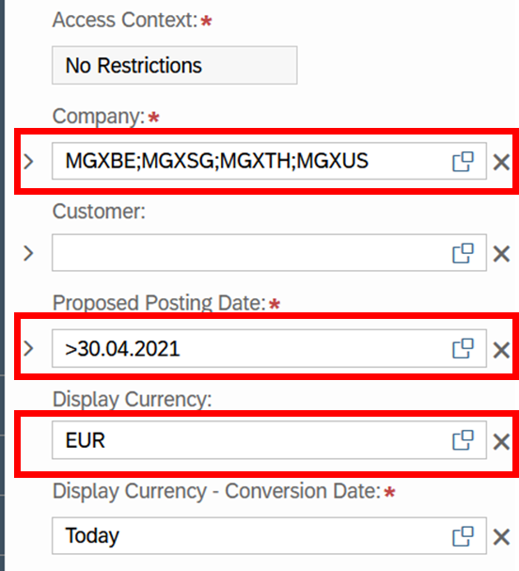

Adjust parameters by clicking the squares and selecting the correct parameter + OK:

* Company to include the 4 legal entities
* Proposing posing date has to be greater than date of last aging list (date minus 7 days)
* Display currency has to be in euro

In the View tab, adapt the parameters to include the concerned company:

Export list by clicking Share  > Download > Report in Microsoft Excel in XML format

Copy the newly booked payments in the 4th tab

1. Arrange your first tab to show the customers with the highest outstanding amounts first by putting a filter on your Outstanding amount column. Cut the empty lines out of the top lines and add them to the bottom of your receivables list
2. Save the workbook (in .xlsx format) to the Sharepoint and email it to the finance team

